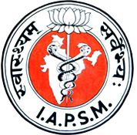

Fellowship in Neonatal and Child Health (FINCH)
(2017-18)

Email the completed application form, along with your recent CV (resume), to “hrb@careindia.org” and copy to academia.iapsm@gmail.comwith the subject line Fellowship application from Indian Association of Preventive and Social medicine (IAPSM).
- Name: ___________________________________

- Age: _____________________

- Gender: ________

- Medical Council of India /State Medical Council registration number: ______________

- Name of State Council: __________________

- Complete postal address: Plot No. ____________________________________

Street/ Area: ____________________________________

City & State: ____________________________________

Pin Code: ____________________________________
- Email id:

- Phone number:

- Relevant qualifications:

- Relevant Experiences:

- Please write why do you want to apply for the Fellowship (in 500 words)

- Please write what would you want to do after the Fellowship (in 500 words)

Place: _____________ Date: __ __ / __ __/ __ __

Last date for submission : 31st May 2017

